DIVERSITY & COLLEGE ACCESS (DCA)– Upward Bound

POSITION: RESIDENTIAL HEALTH CARE & ADMINISTRATIVE ASSISTANT

OVERVIEW: The Diversity and College Access Residential Health Care and Administrative Assistant serves as the primary health care staff member and provides administrative support for Diversity and College Access summer programs, including Upward Bound and English for College (EFC). This position works primarily with Pre-College Residence Hall Director, residence hall staff, instructors, and administrative staff and reports to the Program Advisor. Upward Bound is an academic college preparatory program for low-income and/or first-generation college bound high school students. EFC is an academic college preparatory program for Wisconsin English learner high school students. The primary responsibility is to oversee student health care (dispensing medications, running the residence hall health office, keeping accurate medical records utilizing CampDoc, administering first aid) for DCA summer programs. This position also maintains records and communication between Upward Bound Program Hall staff, instructors, and administrative staff. The ideal candidate will have experience in academic summer residential programs or camps, administrative work, health care and knowledge of TRIO/Upward Bound programs. This is a live-in position.

REQUIRED QUALIFICATIONS:
- Must be enrolled at an institution of higher education (undergraduate or graduate)
- Minimum of 3 years of college course work completed at a postsecondary institution by June 2025
- Minimum 2.75 GPA
- Strong oral and written communication skills
- Strong organizational and time-management skills
- Ability to be flexible, adaptable and team oriented
- Be detail-oriented, as records must be compliant with state and federal policies/regulations
- Valid driver’s license (Must have had for 2 years by June 2025, UW System driver requirement)
- May not be enrolled in or plan to be enrolled in more than 3 credits of summer coursework during the six-week period of the summer camp.
PREFERRED QUALIFICATIONS:
- Pursuing a major in Nursing, Pre-Med, Athletic Training or Health Care or related field
- Minimum 3.0 GPA
- Current certification in First Aid, Adult CPR and/or Basic Life Support
- Certified Nursing Assistant Certification
- Experience in working with residential summer programs or camps
- Familiarity and sensitivity with educationally disadvantaged and limited income students
- Ability to work in a fast-paced environment
- Experience working in an office setting
- Ability to use discretion and maintain confidentiality (i.e. FERPA and HIPPA guidelines)
- Proficiency in using technology and Microsoft Office applications
- Knowledge of Upward Bound and other TRIO Programs
DUTIES:
- Collect, safekeep and dispense prescription and over-the-counter medications to students enrolled in DCA summer camps (Upward Bound, English for College, etc.)
- Maintain accurate medication and health care records on DCA summer camp participants through CampDoc
- Administer first aid to DCA summer camp participants and maintain records
- Escort students to local Urgent Care/Hospital if needed
- Monitor the log of Upward Bound students leaving program for weekends, appointments, etc.
- Co-manage the Upward Bound student financial stipend process with UB Program Advisor
- Monitor and compile data records for USDA Summer Food Service Program
- Assist with shopping for Upward Bound school and activity supplies, and groceries
- Assist Upward Bound Administrative staff with ordering food items for meals and snack
- Take photographs during class sessions, fieldtrips, program activities and compile a UB Summer Session “yearbook” and/or slide shows
- Organize and manage front desk area of in the residence hall
- Escort summer work study students to and from their work placements on campus
- Organize, store and secure supplies needed for program activities in the residence hall
- Ensure kitchens, common spaces and environment outside of residence hall are kept picked up and clean
- Chaperone fieldtrips and activities as assigned
- Assist the Upward Bound administrative staff in the UB offices with general office duties (making copies, delivering supplies to teachers and the residence hall, making signs, etc.)
- Step in for Residence Hall Director on their day off
- Other duties as assigned

OTHER: This position requires an elevated level of responsibility. Background checks are performed on all applicants interviewed. It is the policy of the University of Wisconsin - Stevens Point to provide reasonable accommodation to qualified individuals with a disability.

DATES OF EMPLOYMENT & SALARY: June 12, 2025 – July 24, 2025. This is a short-term temporary position that runs 24 hours per day with 1 day off per week and is contingent upon federal grant funding. Total salary: $4,100 - $4,400 depending upon experience. HOUSING AND MEALS DURING THESE DATES ARE FREE TO EMPLOYEES.

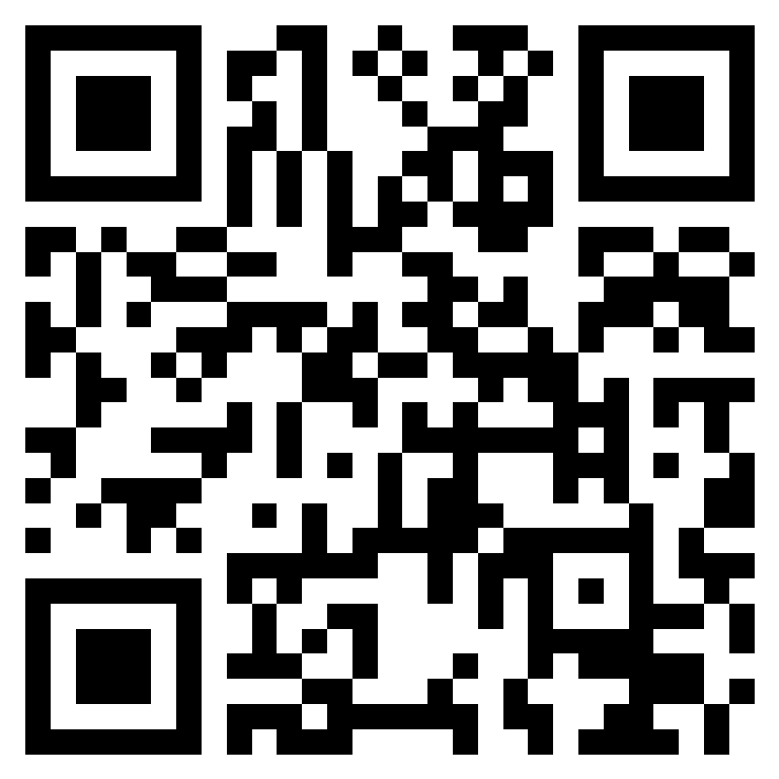
APPLICATION PROCEDURE & DEADLINE: Complete online application by scanning the QR code or using this form, https://forms.office.com/r/YFdsj9EUEC. Completed application materials must be received no later than February 17, 2025.

