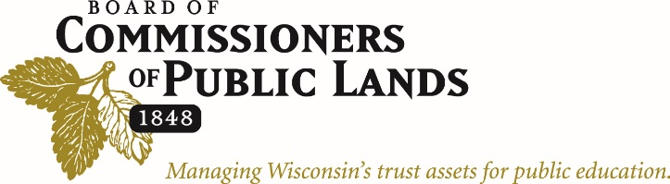

UWSP-CNR Students:

The Wisconsin Board of Commissioners of Public Lands will be hiring two summer students in conjunction with the UWSP-CNR for the summer of 2025. These positions will aid in pre-sale evaluations and timber sale set-up activities. The two Student Foresters will work together after being fully trained by our staff. This work will be conducted on timber sale sites that have already been field reviewed and approved for set-up by our permanent staff. All field work and completed pre-sale reports and maps will be reviewed by permanent staff, and feedback will be provided as needed. BCPL staff will arrange other natural resource projects and learning opportunities based on the individual interests of each Technician.

Ideal candidates should have taken Dendrology, Mensuration and Silviculture or be enrolled in Silviculture. Candidates should have completed the CNR Summer Field Experience and the UWSP Timber Marking class or have at least one summer of work experience in a forestry internship (timber marking/cruising). Applicants must possess a UWSP (State Vehicle) driving permit https://fleetportal.wi.gov/VUA/ViewMyVUA.

These positions will run concurrently with the CNR Summer Field Experience Program with a full week off between the two sessions (4th of July week). All meals and lodging will be provided at the Treehaven Campus near Tomahawk Wisconsin. Wages will be $16.00 per hour and are administered under the UWSP student payroll system. These are both 40-hour per week positions, which are typically worked as four, ten-hour days per week but will vary depending on weather and scheduling. Field work typically continues rain or shine; however, we do have a limited amount of indoor “inclement” weather projects.

The Student Foresters will be fully immersed in an active timber sale program, along with all the items and issues that must be identified and appropriately addressed to ensure a successful timber sale. Students will gain experience utilizing the skills learned in school, in an applied real-world situation.

Applicants must submit a cover letter and resume. Application deadline is January 31, 2025.

Thanks,

Joe Malinowski
BCPL – Senior Forester

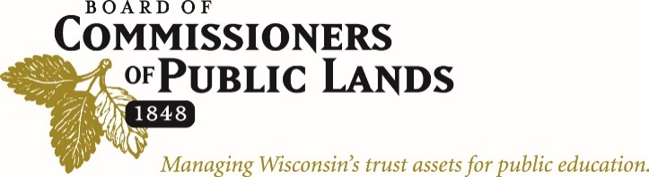

Position Description: Student Forester (summer position)

The Student Forester is a member of a team that manages approximately 78,000 acres of State Trust Lands in 32 counties for the Wisconsin Board of Commissioners of Public Lands (BCPL). BCPL has a very active timber sale program and conducts a wide range of activities to improve the asset value of the Trust Lands and to maintain ecological integrity. This position performs physical work related to timber sale preparation and planning, as well as office tasks such as compiling reports, work scheduling, etc. The Student Forester may also support land management and real estate staff with field inspections, T&E species inventories, GPS and field mapping work, etc. This position reports directly to the BCPL Property Manager where they will be working and is based out of BCPL's Lake Tomahawk Field Office.

80% - Timber Pre-Sale Assistance
- Conduct pre-sale timber inventory to acquire information for planning silvicultural treatments.
- Complete a Timber Sale Recon Report & Harvest Plan Form for each cover type on the sale area.
- Research and propose silvicultural treatments to maximize revenue and conserve ecological integrity.
- Re-mark property boundary lines, mark cutting unit lines, and mark timber for harvesting.
- Locate and map T&E species (plant & animal) that could be impacted by a timber sale.
- Locate and map invasive species within the timber sale area.
- Identify rare/unique micro and macro vegetation types (high conservation value areas).
- Locate, map, and mark logging access roads and landings.
- Locate, map, and mark no cut buffer zones (LMZ, RMZ, etc.).

20% - Miscellaneous Assistance
- Conduct post-harvest evaluations and treatment assessments.
- Utilize field GIS/GPS, to accurately obtain spatial measurements and collect tabular attributes.
- Maintenance of office building and grounds.
- Ride-along or other learning opportunities as they arise.

Knowledge, Skills and Abilities:
- Have an interest in sustainable forest management with a strong financial objective.
- Knowledge of Wisconsin logging operations and forest products.
- Ability to identify and understand the need to conserve T&E species and high conservation value areas.
- Ability to recognize indicator plants, invasive species, and forest insects and diseases.
- Knowledge of field and office technology (Avenza Maps, ArcGIS Field Maps, Microsoft Office products).
- Ability to establish and maintain effective working relationships with fellow BCPL employees.
- Ability to work independently and within a small team.
- Ability to maintain organization, work with attention to detail, and efficiently manage time.
- Familiar with the safety, maintenance and use of company vehicles and forestry equipment.

