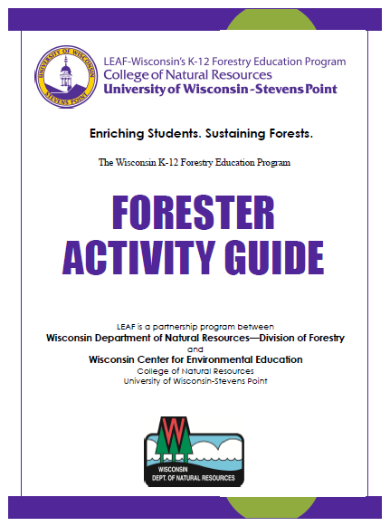
Tips for Using LEAF’s Forester Activity Guide
Gina Smith, WCEE Resource Specialist, November 2022
LEAF’s Forester Activity Guide is available to help you prepare age-appropriate, interactive, outdoor (modifiable to indoor) programs or activities for youth in grades Kindergarten through twelve. Each activity in the guide enriches existing lessons from the LEAF Wisconsin K-12 Forestry Lesson Guide that all educators throughout Wisconsin have free access to.
The Forester Activity Guide can be downloaded and printed from the LEAF Website: https://bit.ly/LEAF_website_foresters . When visiting the website, there is the option to download the complete activity guide or just the materials needed for any one of the guide’s five themes: What Do Foresters Do?, Caring for the Forest, Forest Products / Benefits, Tree Planting & Natural Restoration and Fire.
When examining themes within the guide, you will notice that primary and secondary objectives are listed at the start of each theme. These objectives were determined by the team of foresters who partnered with LEAF. Special attention was given to ensure all objectives link to one or more of the DNR Division of Forestry Key Target Messages and at least one of the Wisconsin Standards for Environmental Literacy and Sustainability. The objectives clearly state what students should learn by the end of the activity and should provide the structure for your presentation.
After reviewing the primary and secondary objectives, you will find information on what you need to do to prepare for each lesson and the materials you’ll need to gather for the different activities within it. Modifications for different audiences and settings (urban, indoors, outdoors) are also listed to help you tailor your presentation for each group of students you encounter. Please remember that the modifications are general and that each group of students will have their own unique characteristics that may require additional flexibility on the day of your program.
The main lessons and activities are presented next and are similar to a script. They describe what and how you should complete the lessons and activities and even give you suggestions on what to say and questions to ask. Prior to each event you engage in, you will want to take time to review the entire lesson and determine which aspects will work best with your audience – and even make notes/reminders to help you on the day of your presentation. Many lessons have multiple options to consider and are not intended for the entire lesson to be used in one visit. Each lesson will conclude with a review of the key messages which link back to the primary and secondary objectives.
Following the lesson, you will find a combination of optional activities related to the theme, links to videos or other materials that can be used, recommended LEAF teacher resources to support the theme, and print resources that are needed for activities in the theme. The foresters and LEAF staff have covered all the bases in preparing materials that are both effective and efficient for you to use.
Finally, to make things even easier, LEAF has also created a LEAF Forester Lesson Repository in a shared google drive folder. The repository contains the lessons, letters, activity resources, and slideshow presentations for each theme in the Forester Activity Guide. The letters are specific to each theme and when downloaded from the google folder, they can be modified to include information related to the educator you are visiting and your signature. The confirmation letter includes the primary objectives for the theme whereas the follow-up letter includes recommended LEAF lessons that educators can utilize after your visit. While the lesson pdf and activities in the google folder are the same as in the downloadable files from the LEAF website, the slideshows are unique to the LEAF Forester Lesson Repository. Slideshows were created for each theme and can be opened and used as is or modified to include your personal preferences. Slideshows include all activities from the lesson and often have additional features like links to short videos (specifically forestry careers) and images that support each lesson. The LEAF Forester Lesson Repository can be accessed using this link: https://bit.ly/LEAF_ForesterActivities .
Please note, google was selected as the platform for the repository because it is the most widely used platform by educators throughout the state of Wisconsin. LEAF thought creating additional resources to share via this platform would make it easier for educators to have your presentations ready for projection when you visit their classroom. Furthermore, shared google slideshows, even if they weren’t used by you during the presentation, allows teachers to access all resources from the lesson and links to all recommended LEAF activities they can use in their classroom.
LEAF and the forester team who worked on the updated Forester Activity Guide hope you will consider using the guide for your next student engagement.

