WI DNR Foresters Partner with LEAF Program to Update Forester Activity Guide
Gina Smith, WCEE Resource Specialist, October 2022
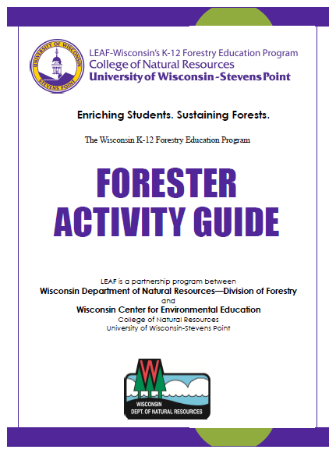
In 2008, LEAF – Wisconsin’s K-12 Forestry Education Program created a Forester Activity Guide. The intent of the guide was to help foresters lead age-appropriate, interactive, hands-on classroom programs for students in grades K through 8 with a minimum amount of advanced preparation. The guide was promoted to foresters throughout Wisconsin and even included as part of programming during new forester orientation.
In the fall of 2021, LEAF staff, working with Kirsten Held, determined that an update to the guide was overdue. To be certain a new guide would meet the needs of current foresters, LEAF sought input from professionals around the state who have both field experience and an enthusiasm for working with students. With permission from supervisors, Brooke Ludwig, Eau Claire; Steven Kaufman, Oconto Falls; Kara Oikarinen, Washburn; Scott Mueller, Medford; Sarah Ward, Montello; and Brian Wahl, Fitchburg, partnered with LEAF to create a new and improved Forester Activity Guide.
The new Forester Activity Guide builds upon the goals set for the original K-8 guide by including more opportunities for outdoor learning around themes that foresters are frequently asked about: What Do Foresters Do?; Caring for the Forest; Forest Products & Benefits, Tree Planting and Natural Restoration, and Fire. All activities include tips for modifying lessons to urban settings and suggestions on how to use the lessons with learners from grades K through 12. Lessons in the new guide all have slideshow presentations that foresters can use if their visits must take place in an indoor setting and require even less advanced preparation than lessons for the original guide.
LEAF is grateful for the time and effort the team of foresters devoted to this project and is excited to share their work with all foresters. Look for articles in future newsletters for information on how to access the NEW Forester Activity Guide and insights about each of the five forester guide themes.

